The Honorary Secretary Report for 2025

There have been 5 general meetings of the Association.
The first meeting followed the 2024 AGM.

All the meetings this year were held ONLINE except the one which followed the AGM
The November AGM and business meetings were held in the YOAC clubhouse

November 20th after the 2024 AGM
January 2025
April 2025
July 2025
September 3rd, 2025

Attendance of your officers at these meeting was as follows:

Date | BMR | DC | JW | GC | SH | RB | Total delegates
Nov 20 | Y | Y | Y | Y | Y | Y | 6
Jan 29 | Y | Y | N | Y | Y | Y | 5
April 16 | N | Y | Y | Y | Y | Y | 5
July 2 | Y | Y | Y | Y | Y | Y | 6
Sep 3 | Y | Y | Y | Y | Y | Y | 6
Total | 5 | 6 | 5 | 6 | 6 | 6

BMR Brian Mountjoy-Row, DC David Cooke, GC Geoff Cole, SH Sally Higman,
JW Justin Worringham, RB Richard Bowden

8 of the 21 affiliated clubs were represented at one or more business meetings:

Mendip AC
Taunton AC
Yeovil Town RRC
Wells City Harriers
Frome RC
Yeovil Olympiads AC
Academy of Combined Events (ACE)
Minster Milers

The following bodies were also represented during the year:

Somerset Schools (Richard Bowden)

There are 21 affiliated clubs in the Association in the year 2025:

CLUB | VOTING REPRESENTATIVE
Academy of Combined Events (ACE) | Peter Grosjean
BHAM | Neil Brannagan-Fuller
BADRAT | Megan Lane
Burnham on Sea Harriers | Stephen Dorrall
Quantock Harriers | Neil Haigh
Chard Road Runners | Wayne Loveridge
Cheddar Running Club | Chris Walker
Crewkerne Running Club | Martin Cook
Frome RC | Justin Worringham
Hydro Harriers | Andrew Longthorpe
Langport Runners | Julie Gilbert
Mendip AC | Peter Grosjean
Millfield School AC | Neil Wheeler
Minehead Running Club | Martin Shoots
Minster Milers | John Cusack
Running Forever Running Club | Simon Denson
Taunton AC | Julie Singleton
Wells City Harriers | Alan Thorner
YBR Running Club | Roxanne Clements
Yeovil Olympiads AC | Paul Guest/Emma Trickey
Yeovil Town Road Running Club | Brian Mountjoy-Row

The County AA welcomed two new clubs to the Association in 2025 – namely Badrat Runners based at Chilton Trinity, Bridgwater and YBR Running Club based at Pawlett, Bridgwater

Significant Business in the year 2025

Geoff Cole is Chairman and Roger Lee is the current President of the Association

At the 2024 AGM, Eleanor Brock was awarded the Jim Brunton trophy for services to athletics in the County in the year of 2024

The Sue Somerset trophy
The Sue Somerset trophy for the best performance at the 2025 T&F championship was awarded jointly to Toby Wright (110mH) and Dillon Millard (2000mSC) – both Taunton AC
New trophies were purchased after the current stock had been expended – see image below
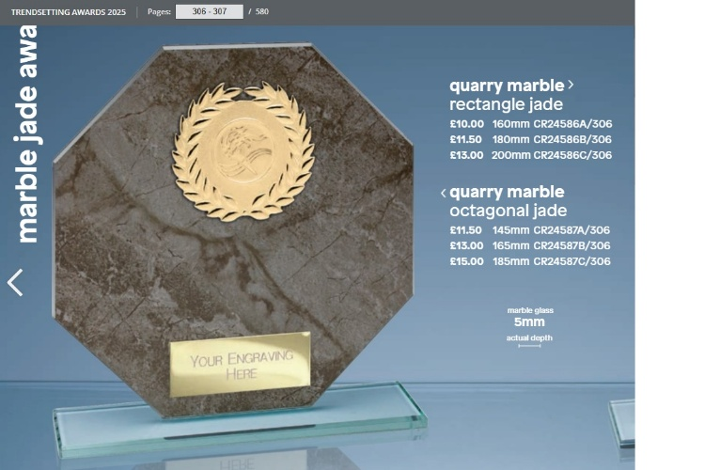

XC/RR/T&F
The Tri-County XC championship was hosted by Avon AA and held at the University of Bath in December 2024

The County AA did not offer a marathon championship this year.

Indoor T&F meetings were held in Cardiff over the winter of 2024-2025. Some of those meetings included SW championships and several Somerset AA athletes were present at those meetings.

Somerset AA held their T&F championship at Yeovil 11th/12th in conjunction with SWVAC, Disability Sport Wales and (with a limited number of events) with Avon AA

The SW Inter-County RR challenge was incorporated in the Chippenham Half Marathon in September 2025 but, sadly, Somerset AA was unable to field teams.

Somerset teams
The County sent teams to:
The CAU Inter-County XC championship (with Avon AA)
The SW Inter-County track and field championship
In 2025, the County did not sent teams to the SEAA U15/U20/Senior Inter-County championship nor the Southern U13 Inter-County
The County was not able to send a team (with Avon) to the National Fell Running championships but some athletes did compete as individuals
New vests were purchased as current stocks were low. The new design shows the text ‘Somerset’ front and back. Clubs were circulated with notes on sizes and prices.

The County was able to promote and co-promote Officials’ courses.

The Association continues to explore relevant documents with regard to a Privacy Policy for the County website and our position with regard to a transgender policy.

David Cooke continues as website manager and has taken on the interim role of team manager and XC secretary

Disability athletics continues to be part of the structure of the County administration although we understand that the infrastructure in the local clubs is not developing and we have no Officer for this category

The County AA continues its close association with Somerset Schools AA.

SW COUNCIL
David Cooke (Track and Field) completed his term of office on the SW Council but continues as a co-opted member.
Richard Llewellyn-Eaton continues to serve on the SW Council.
Paul d’Arcy (YOAC) is now the chairman of that committee.

DC summarized SW Council reports at the SCAA business meetings.
Those minutes are available online at http://www.athleticssouthwest.org.uk/

Honorary Life Vice-President
An award for Honorary Life Vice-President was instituted at the 2024 AGM

David Cooke 19/11/2025

